SIMATS ENGINEERING (SAVEETHA SCHOOL OF ENGINEERING)
Department of Computer Science and Engineering
ASSESSMENT TOOL 2 – SCENARIO BASED ASSESSMENT
Course Code: | CSA0621 |  | Course Title: | Design and Analysis of Algorithms
CO Assessed: | CO2 – Manipulation (BL1, BL2, BL3) |  | Assessment: | Assessment Tool 2 – Scenario  Based Assessment
Weightage: | 20% of CIA |  | Total Marks: | 100
CO2 Statement: | Apply Brute Force technique to solve sorting, searching, Closest-Pair and Convex-Hull problems  (BL1, BL2, BL3)
Student Name: | Ch.Akhil |  | Reg. No.: | 192525250
Section / Batch: | 2025-2029 |  | Date: | 31-07-26
Instructions to Students
- Answer BOTH scenario-based questions. Each question carries 50 Marks. Total: 100 Marks.
- Carefully analyze the given scenario and identify the computational problem involved.
- Apply appropriate Brute Force techniques for sorting, searching, Closest-Pair, and Convex-Hull problems wherever applicable.
- Clearly justify the chosen solution approach with proper reasoning and analytical interpretation.
- Demonstrate decision-making skills by comparing possible solutions and selecting the most suitable approach.
- Use diagrams, stepwise illustrations, or algorithmic representations wherever necessary.
- Maintain clarity, logical organization, and proper technical presentation throughout the answers.
Question Type |  | Focus Area |  |  | Questions Marks
Scenario Based Assessment |  | Analyze real-world scenarios and apply Brute Force techniques for sorting, searching, Closest-Pair, and Convex-Hull problems |  |  | Q1 - Q2 | 100 (2 × 50)
 |  | GRAND TOTAL: |  |  | 100 Marks
SECTION A – SCENARIO BASED ASSESSMENT
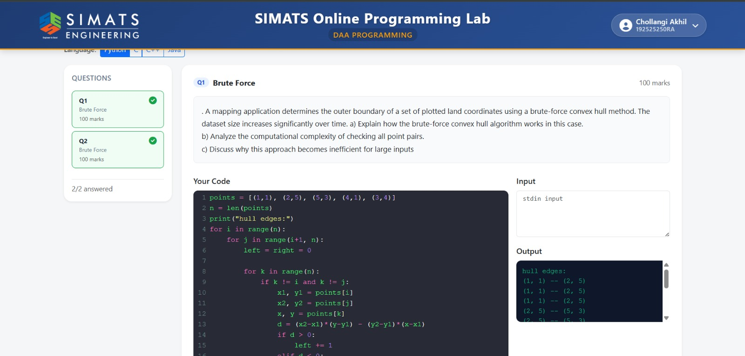
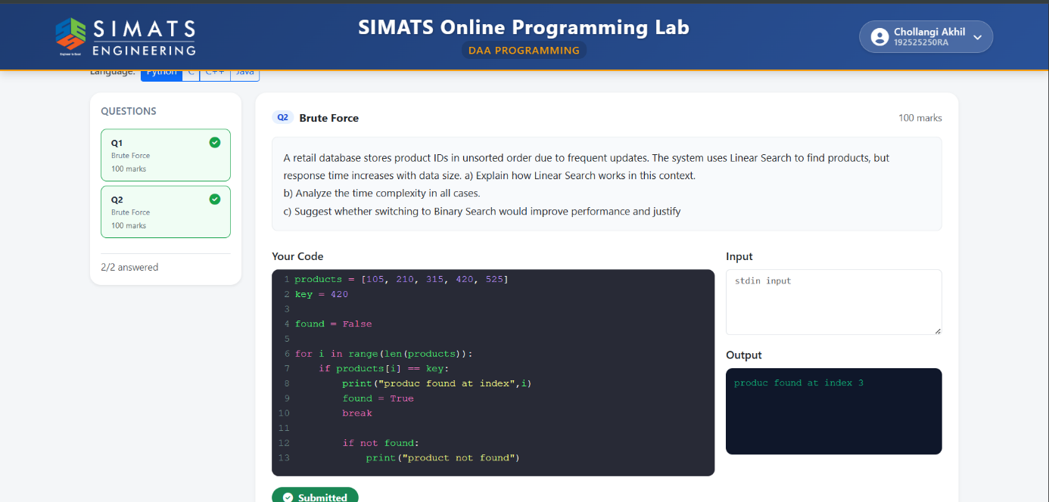
Code of Conduct
I Ch.Akhil (192525250) (Name / Reg No) certify that this submission is my original work and that I have adhered to the guidelines specified for this assessment. I understand that any violation of academic integrity rules will result in disciplinary action.
Signature of the Student: ch.akhil
Question | Problem | Application | Analytical & | Solution | Clarity, | Total
RUBRICS FOR CALCULATION

Criteria Wt. |  | Level 4 – Exemplary | Level 3 – Proficient | Level 2 –  Developing | Level 1 –  Beginning
Problem  Understanding  & Context  Analysis | 25 | Thoroughly understands the scenario with accurate  interpretation of all requirements | Clearly understands the scenario with minor gaps | Basic understanding; some aspects of the scenario unclear | Poor understanding or misinterpretation of the scenario
Application of  Concepts | 30 | Applies appropriate concepts effectively to solve complex realworld problems | Applies relevant concepts correctly with minor errors | Applies basic concepts but  with limited accuracy | Fails to apply appropriate concepts
Analytical &  DecisionMaking Skills | 20 | Demonstrates strong analysis and selects optimal solutions with justification | Good analysis with reasonable solutions | Limited analysis; solutions lack justification | Poor or no analysis; incorrect decisions
Solution Design & Approach | 15 | Well-structured, innovative, and  feasible solution approach | Logical and structured solution with minor gaps | Basic solution with limited structure or feasibility | Unclear or incorrect solution approach
Clarity,  Justification &  Presentation | 10 | Clear, well-justified explanation with strong reasoning | Clear explanation with some  justification | Limited clarity and weak  justification | Poorly explained with no justification
Marks Evaluation:

No. | Understanding &  Context Analysis (25%) | of Concepts (30%) |  | Decision-  Making Skills (20%) | Design &  Approach  (15%) |  | Justification &  Presentation  (10%) | Marks  (Each –  50)
Q1
Q2
 |  |  |  |  | Overall Total (100)
Faculty In-charge |  |  | Course Coordinator |  |  | Head of Department
Signature: _______________ |  |  | Signature: _______________ |  |  | Signature: _______________
Date: ___________________ |  |  | Date: ___________________ |  |  | Date: ___________________

